Problem of Critical Path Method (CPM)

**Problem 1**

The following details are available regarding a project:

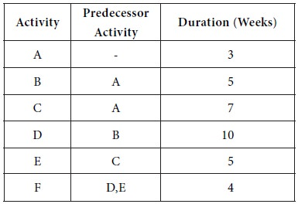

Determine the critical path, the critical activities and the project completion time.

**Solution**

First let us construct the network diagram for the given project. We mark the time estimates along the arrows representing the activities. We obtain the following diagram:

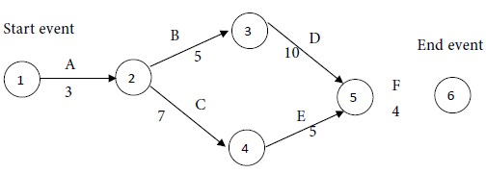

Consider the paths, beginning with the start node and stopping with the end node. There are two such paths for the given project. They are as follows:

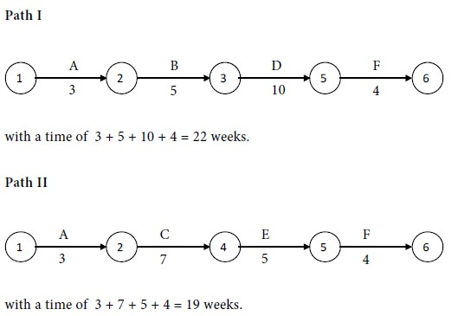

Compare the times for the two paths. Maximum of {22,19} = 22. We see that path I has the maximum time of 22 weeks. Therefore, path I is the critical path. The critical activities are A, B, D and F. The project completion time is 22 weeks.

We notice that C and E are non- critical activities.

Time for path I - Time for path II = 22- 19 = 3 weeks.

Therefore, together the non- critical activities can be delayed upto a maximum of 3 weeks, without delaying the completion of the whole project.

**Problem 2**

Find out the completion time and the critical activities for the following project:

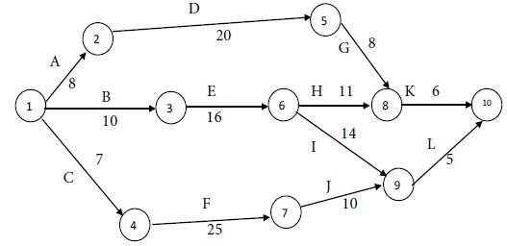

**Solution**

In all, we identify 4 paths, beginning with the start node of 1 and terminating at the end node of 10. They are as follows:

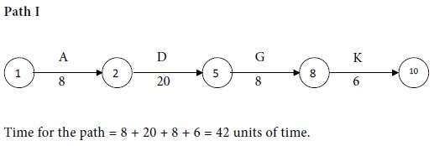

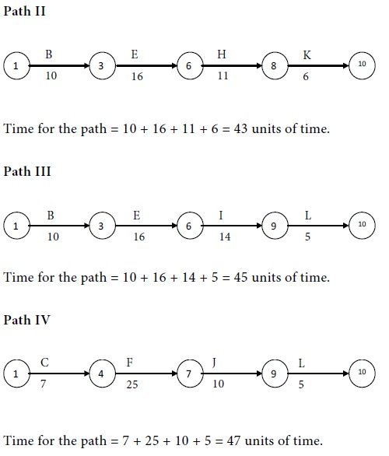

Compare the times for the four paths. Maximum of {42, 43, 45, 47} = 47. We see that the following path has the maximum time and so it is the critical path:

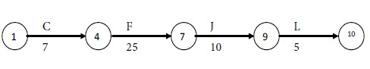

The critical activities are C, F, J and L. The non-critical activities are A, B, D, E, G, H, I and K. The project completion time is 47 units of time.

**Problem 3**

Draw the network diagram and determine the critical path for the following project:

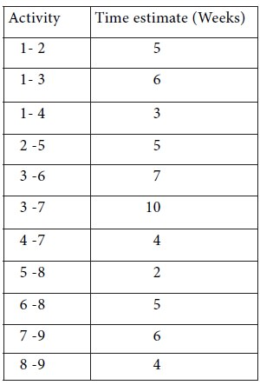

**Solution**

We have the following network diagram for the project:

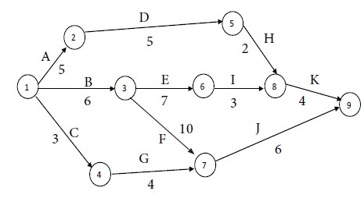

**Solution**

We assert that there are 4 paths, beginning with the start node of 1 and terminating at the end node of 9. They are as follows:

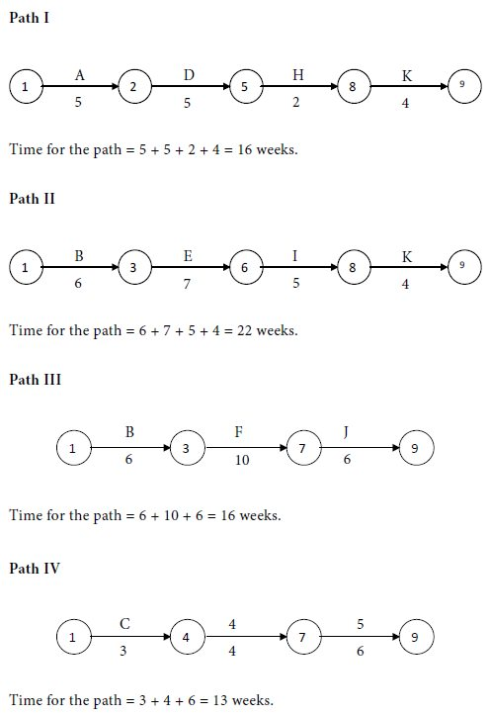

Compare the times for the four paths. Maximum of {16, 22, 16, 13} =  22. We see that the following path has the maximum time and so it is the critical path:

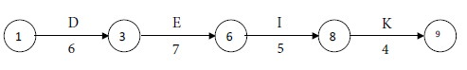

The critical activities are B, E, I and K. The non-critical activities are A, C, D, F, G, H and J. The project completion time is 22 weeks.